How to make comparison tables with CLIC-VAR

1. Make your data file. Needs to be a “.txt” file, the first line needs to have a comment of sorts.

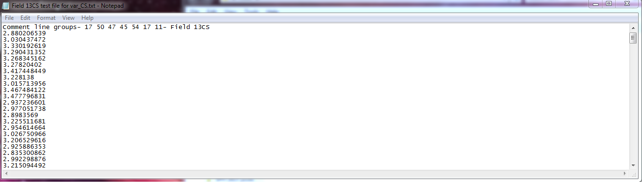

1. Open CLIC->VAR
2. Select file
3. Input groups (key tip is to have groupings in first line of file

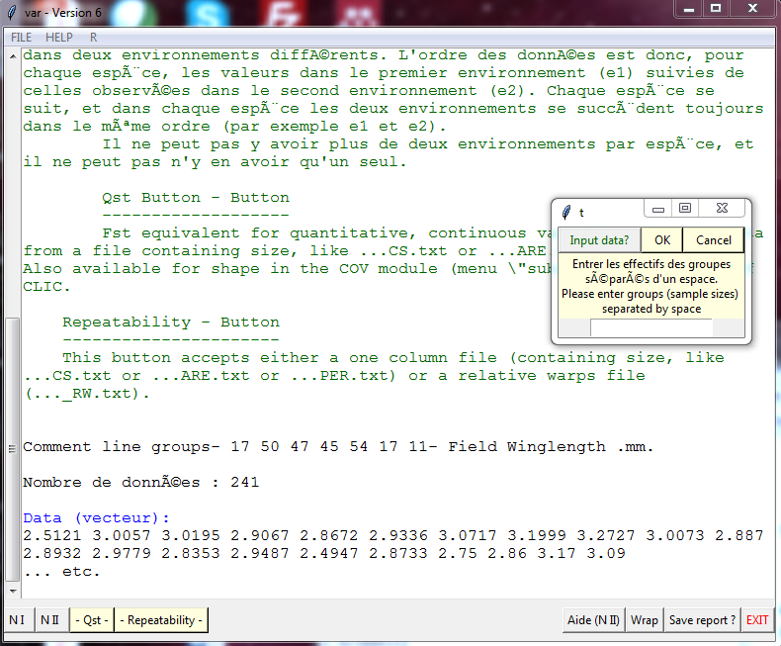

1. Input groups with a space between each
2. Select “N I”  
   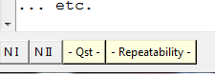
3. A box appears and type in how many permutations (ie 1000)  
   
4. After it runs, you get your results and click “Save report?”  
   